1. Role vs Profile :

A role is controls of records a user can SEE in the hierarchy i.e. which records or objects a user can observe. This role is based on USER’s role in the hierarchy. On the other hand, a Profile is a measure of what a user can do i.e. settings of profile establish control of the visibility of objects, tabs, CRUD, fields, and functions inside an application.

1. How to delete child record in Lookup relationship Salesforce :

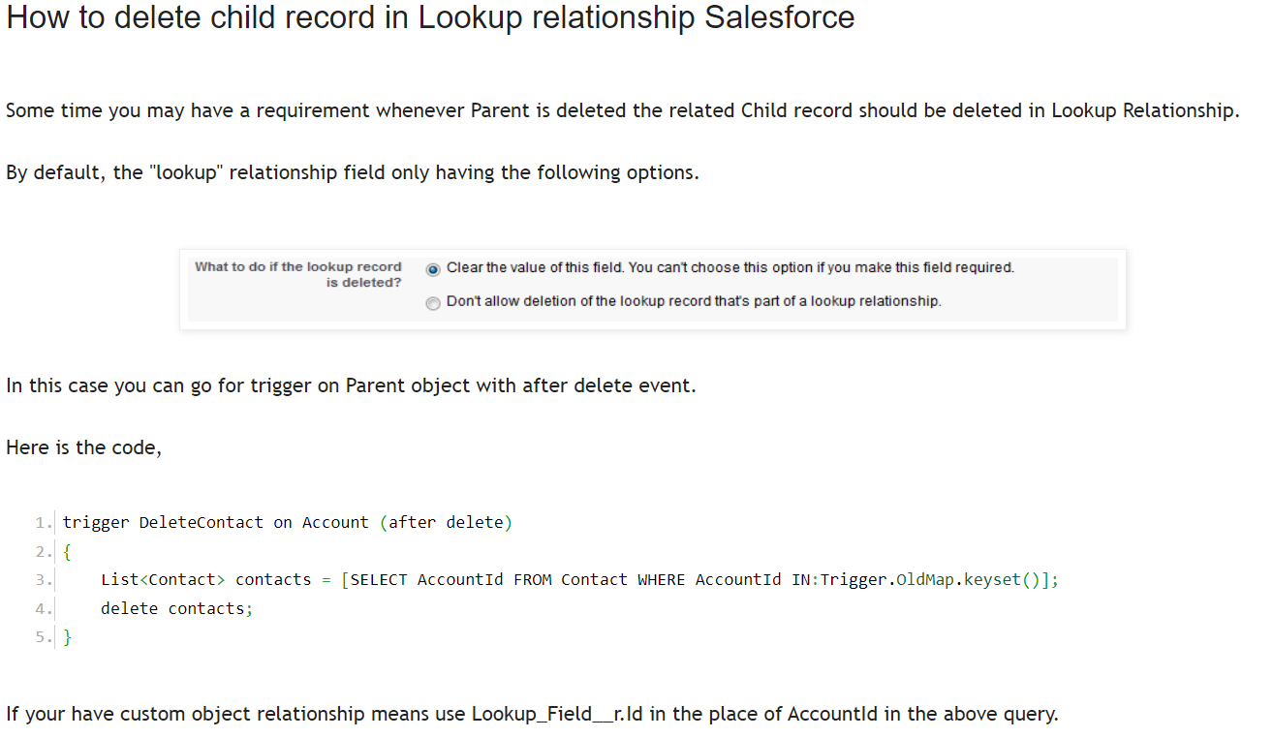

1. Batch apex :

* <https://www.sfdcpoint.com/salesforce/batch-apex-example-in-salesforce/>
* <https://developer.salesforce.com/docs/atlas.en-us.apexcode.meta/apexcode/apex_batch_interface.htm>
* To call one batch from another batch : <https://www.emizentech.com/blog/call-batch-apex-from-another-batch-apex.html>

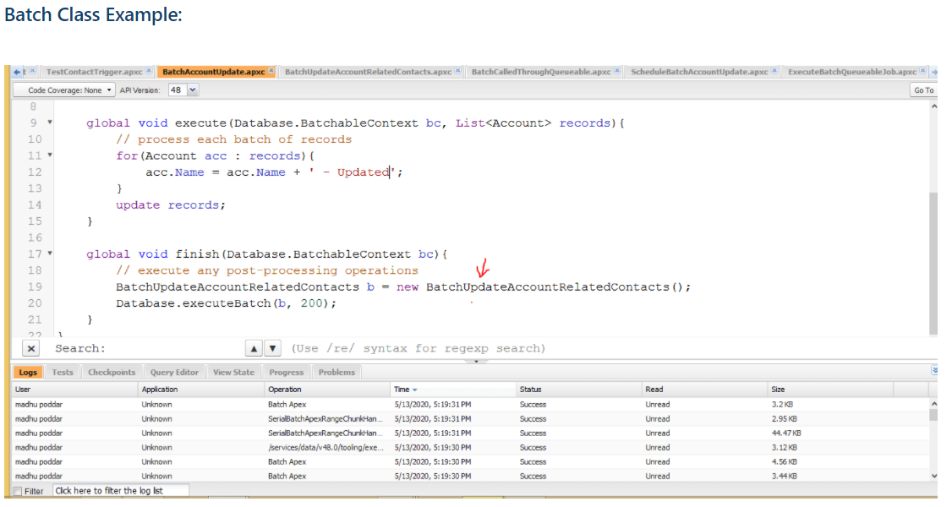

1. When we write Private Methods/ Variables in class, how we test/call from test class?

@TestVisible : When we write private methods or Variables in the class, that time we can use @TestVisible annotation method to access those private Methods/ Variables.

<https://developer.salesforce.com/docs/atlas.en-us.apexcode.meta/apexcode/apex_classes_annotation_testvisible.htm>

1. What is out-of-box functionality till you have done?
2. Trigger events and context variables :
   1. Events :
      1. Before insert, update, delete
      2. After insert, update, delete
   2. Context variables :
      1. Trigger.New
      2. Trigger.Old
      3. Trigger.newMap()
      4. Trigger.OldMap()

Bulk trigger : https://developer.salesforce.com/docs/atlas.en-us.apexcode.meta/apexcode/apex_triggers_bulk.htm

1. How to implement Rollup summary on Master-detail and Lookup relationship?
   1. <http://varasi.com/salesforce/implementing-roll-up-summary-when-you-are-dealt-with-a-lookup-relationship/>
2. Dynamically Get Record Type of Salesforce object using Apex :

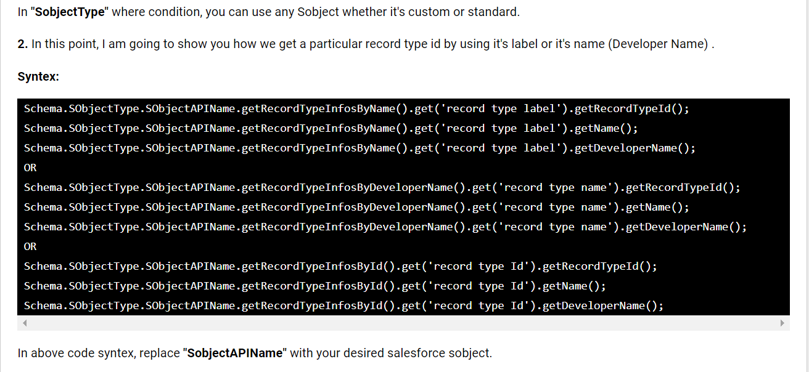

We can get recordtype only by :

* Name,
* Label,
* Id

1. Send an automatic birthday email to Contacts via Workflow Rules

<https://help.salesforce.com/s/articleView?id=000330629&type=1>

<https://www.simplysfdc.com/2015/02/salesforce-send-birthday-email.html>

1. Process Builder vs Lightning Flows :
   1. Lightning Flow is a new Lightning Platform service that empowers any business to create and extend the power of process automation to any customer or employee experience
2. When should developers choose Apex?

Apex should be used when we can’t use pre-built and existing out-of-the-box functionality to implement complex business functions.

1. Junction object?
   1. 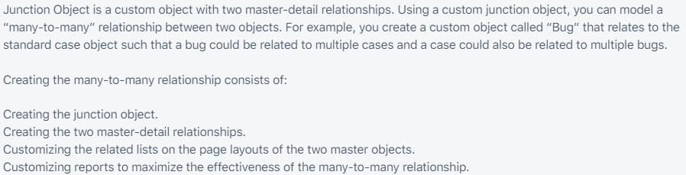
2. Does Apex support switch statements?

Apex does not support switch statements.

1. What is sObject in Apex?

This is a special data type in Salesforce. It is similar to a table in SQL and contains fields similar to those in SQL. There are two types of sObjects: Standard and Custom.

1. Difference between database methods and DML statements?

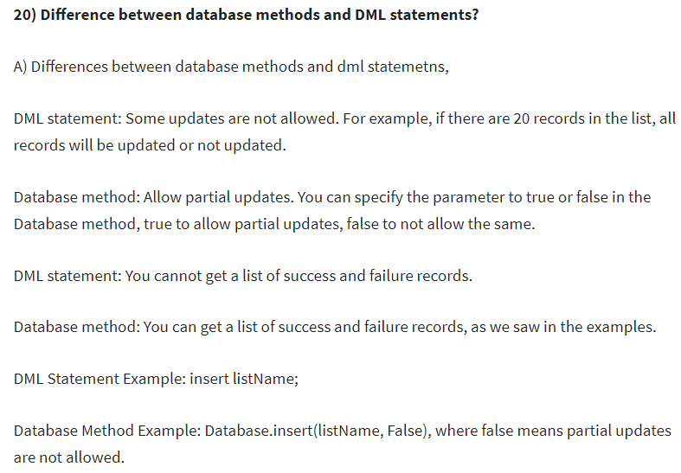

1. SOSL and SOQL :
2. Escalation rule, Case alignments
3. Write a trigger for preventing the user to create duplicate account:

<https://developer.salesforce.com/forums/?id=906F0000000fyhvIAA>

1. Trigger Context Variables :

<https://developer.salesforce.com/docs/atlas.en-us.apexcode.meta/apexcode/apex_triggers_context_variables.htm>

1. Null Vs Undefined :
2. Flexi queue and Vs Future method
3. Collections : List, Set, Map(imp)
   1. Map : <https://developer.salesforce.com/docs/atlas.en-us.apexref.meta/apexref/apex_methods_system_map.htm>
   2. List : <https://developer.salesforce.com/docs/atlas.en-us.apexref.meta/apexref/apex_methods_system_list.htm>
   3. Set : <https://developer.salesforce.com/docs/atlas.en-us.apexcode.meta/apexcode/langCon_apex_collections_sets.htm>
4. Exception handling : <https://developer.salesforce.com/docs/atlas.en-us.apexcode.meta/apexcode/apex_exception_definition.htm>
5. If profile have owd, but FLS doesn’t have permission, then can user access this record?
6. What is Synchronous and Asynchronous in Salesforce.
   1. Synchronous: In a Synchronous call, the thread will wait until it completes its tasks before proceeding to next. In a Synchronous call, the code runs in single thread. Example:
      1. Trigger
      2. Controller Extension
      3. Custom Controller
   2. Asynchronous: In an Asynchronous call, the thread will not wait until it completes its tasks before proceeding to next. Instead it proceeds to next leaving it run in separate thread. In an Asynchronous call, the code runs in multiple threads which helps to do many tasks as background jobs.

Example:

1. Batch
2. @future Annotation
3. Future Annotation :

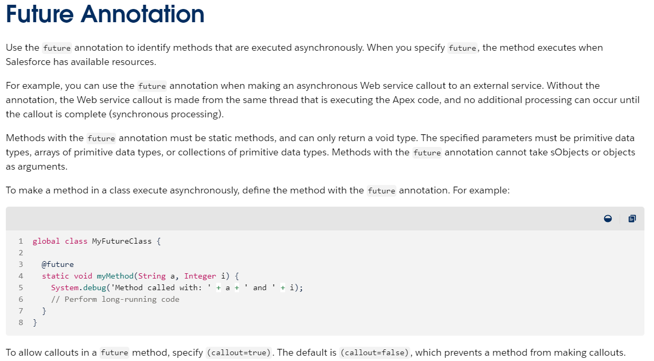

Ref : <https://developer.salesforce.com/docs/atlas.en-us.apexcode.meta/apexcode/apex_classes_annotation_future.htm>

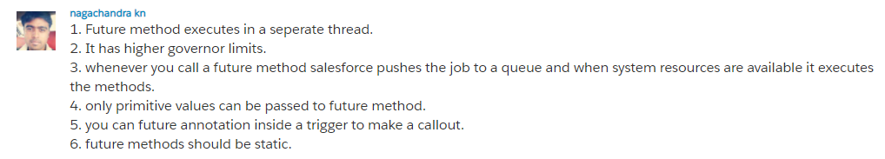

1. Mixed DML : When you try to update an account(Non setup) record and a User(setup) record at the same time in same transaction with some list ,then usually we will get an error. Maybe update or insert any dml operation you consider.

Ref : <https://developer.salesforce.com/docs/atlas.en-us.apexcode.meta/apexcode/apex_dml_non_mix_sobjects_test_methods.htm>

Future method will bypass the mixed DML error in a Test Method.

1. Custom settings and Custom metadata ?? Still need answer
   1. Main difference between custom metadata and custom setting is that custom metadata records are deployable and packageable. But we cannot deploy custom setting data. Custom settings enable you to create custom sets of data, as well as create and associate custom data for an organization, profile, or specific user.
   2. <https://www.biswajeetsamal.com/blog/difference-between-custom-settings-and-custom-metadata-types/>
   3. <https://developer.salesforce.com/forums/?id=9060G0000005YjuQAE>
   4. Video for Custom settings : <https://www.youtube.com/watch?v=y5VPnuCUvsQ>
   5. Custom Metadata : <https://trailhead.salesforce.com/en/content/learn/modules/custom_metadata_types_dec/cmt_overview>
2. How to write apex trigger for parent and child object when child record is executed.

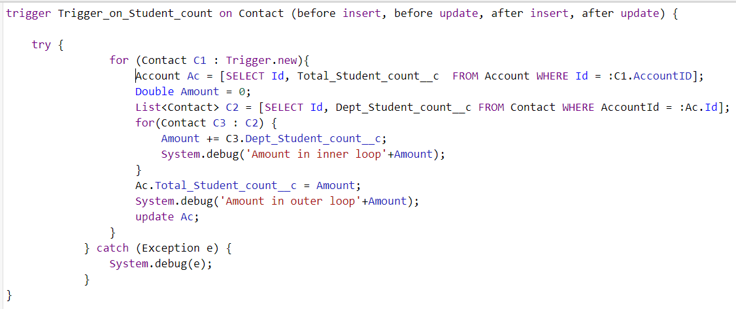

Scenario is : When Contact amount is inserted or updated of the associated Account Total amount should be reflected

1. Data Loader : <https://developer.salesforce.com/docs/atlas.en-us.232.0.dataLoader.meta/dataLoader/data_loader.htm>
2. Invocable methods : <https://www.emizentech.com/blog/call-apex-class-from-process-builder.html>
3. Annotation : <https://developer.salesforce.com/docs/atlas.en-us.apexcode.meta/apexcode/apex_classes_annotation.htm>
4. Call future method from Invocable method :

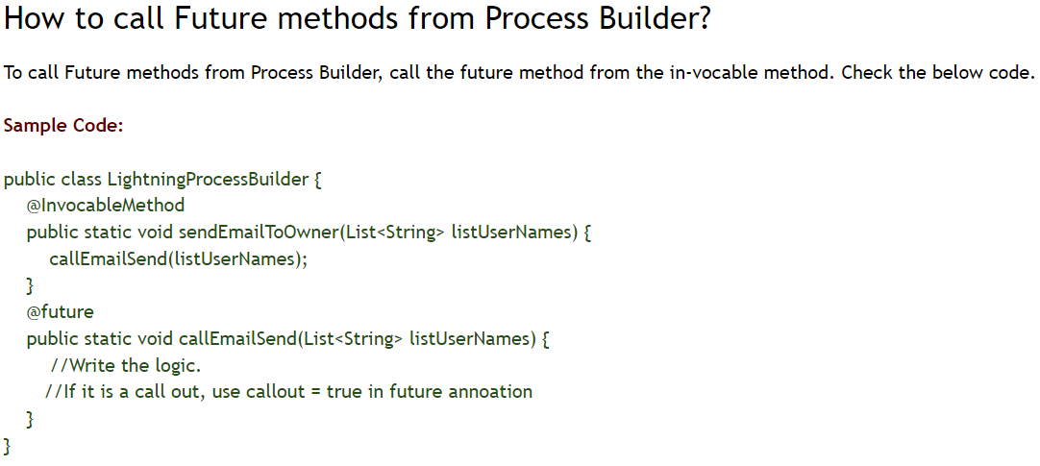

1. Apex Modifiers :
2. Authentication and Authorization : <https://auth0.com/docs/get-started/authentication-and-authorization>
3. User mode and System mode :
4. Governors and Limits : <https://developer.salesforce.com/docs/atlas.en-us.apexcode.meta/apexcode/apex_gov_limits.htm>
5. Can we directly delete apex class in PROD? :

* Stateful : Use Database.Stateful with the class definition if you want to share instance member variables or data across job transactions. Otherwise, all member variables are reset to their initial state at the start of each transaction.

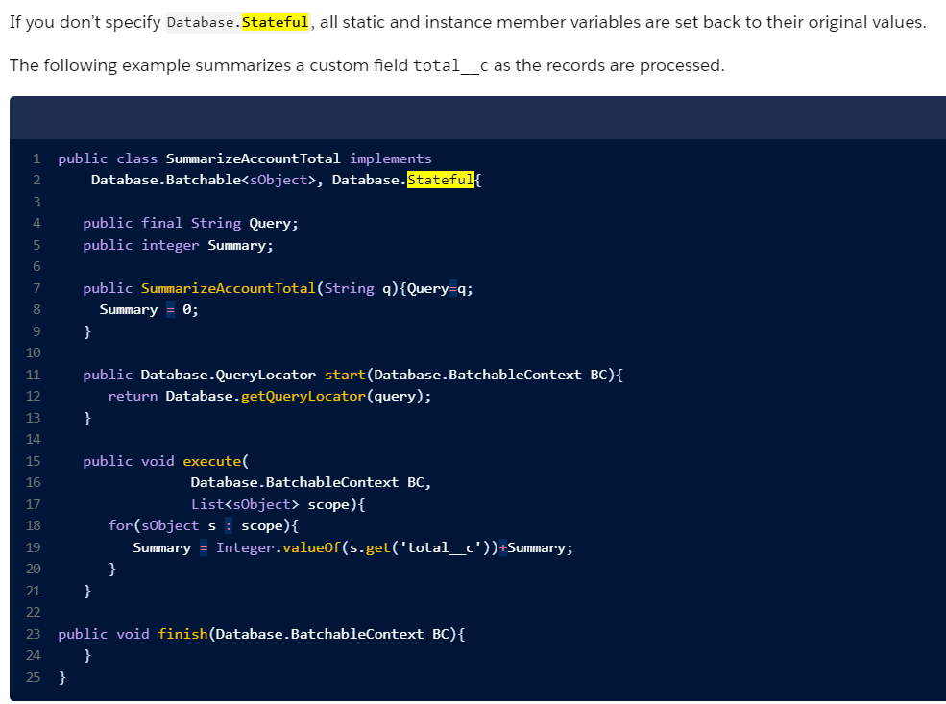

1. Bucket field :
2. How to convert 15-digit ID to 18-digit ID L
3. Order of salesforce execution :

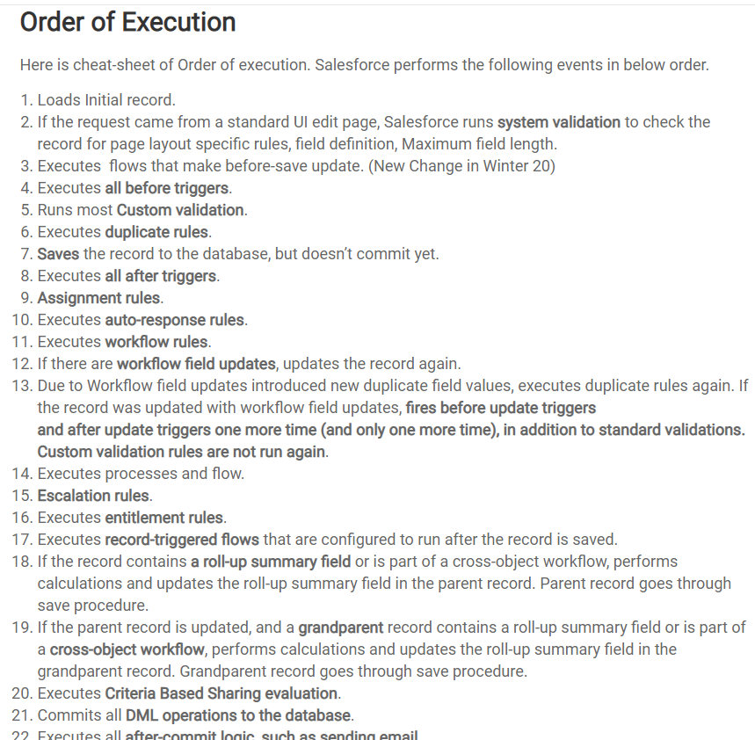

1. Test class best practices :

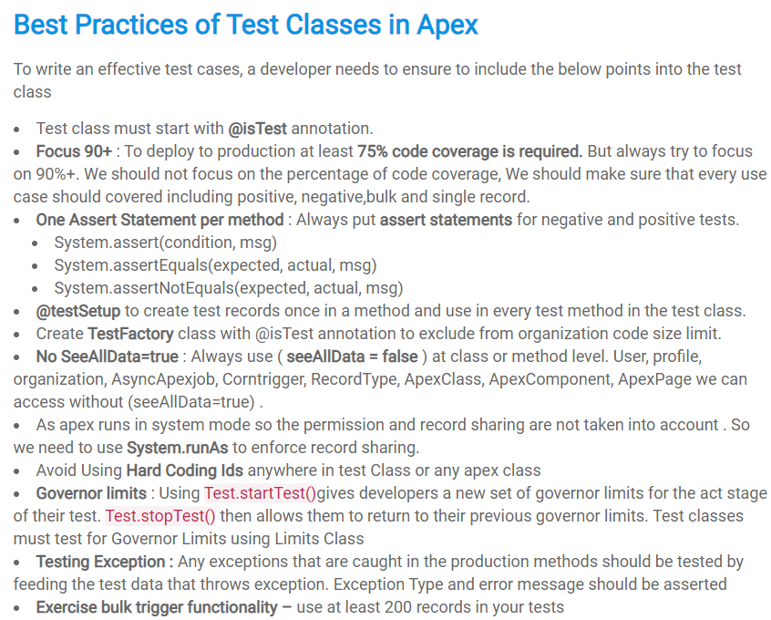

1. Trigger best practices :
2. DML and Database Class Methods :

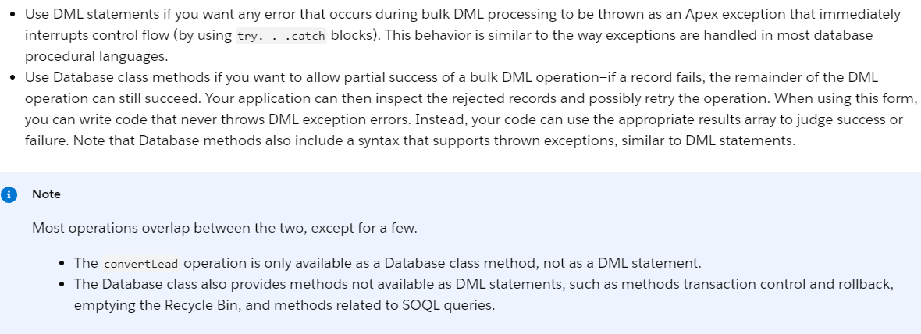

1. Revoke permission for particular profile users :

<https://developer.salesforce.com/docs/atlas.en-us.securityImplGuide.meta/securityImplGuide/permissions_revoking_access.htm>

